SUPPLEMENTARY INFORMATION

Profiling anti-Neu5Gc IgG in human sera by a sialoglycan microarray assay

Shani Leviatan Ben-Arye¹, Hai Yu², Xi Chen² and Vered Padler-Karavani¹

¹Department of Cell Research and Immunology, Tel Aviv University, Tel Aviv, 69978, Israel; ²Department of Chemistry, University of California-Davis, Davis, CA 95616, USA

E-MAIL ADDRESSES:
Shani Leviatan Ben-Arye (leviata@post.tau.ac.il)
Hai Yu (hyu@ucdavis.edu)
Xi Chen (xiichen@ucdavis.edu)
Vered Padler-Karavani (vkaravani@post.tau.ac.il)

CORRESPONDING AUTHOR: Department of Cell Research & Immunology, The George S. Wise Faculty of Life Sciences, Tel-Aviv University, Tel Aviv 69978 Israel. Tel: +972-3-640-6737. Fax: +972-3-642-2046. E-mail address: vkaravani@post.tau.ac.il

KEYWORDS:
Sialic acid, N-acetylneuraminic acid, Neu5Ac, N-glycolylneuraminic acid, Neu5Gc, carbohydrate, antibodies, lectin, glycan microarray, cancer, diagnostics, high-throughput assay

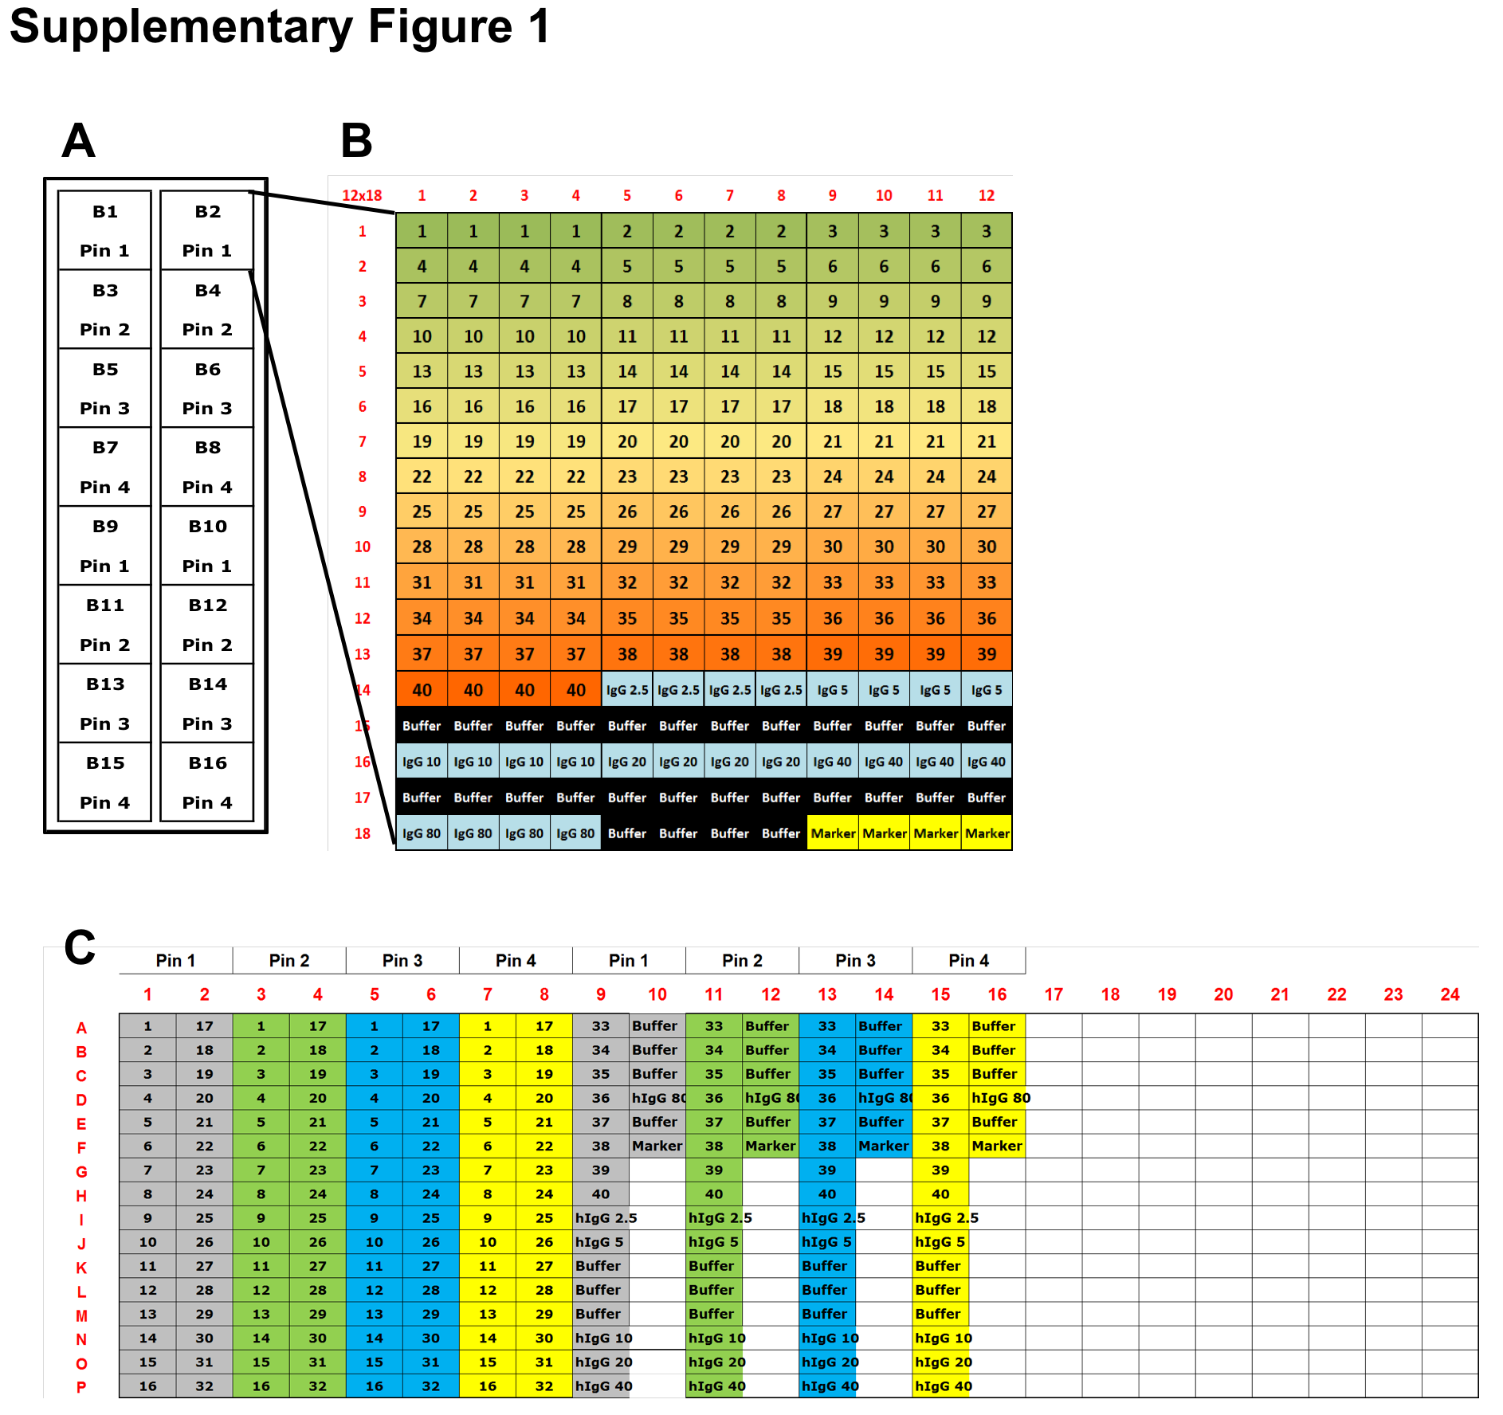

Supplementary Figure 1. Slide, Pins and Blocks layout. A) Slide and pins layout. Each slide contains 16 Sub-arrays, also called Blocks (numbered B1, 2…16), each block contains a complete array of 40 Sia-containing glycans, 6 points STD curve of human IgG and a fluorescence marker. B) Block layout of 12 columns and 18 rows. Each sample is printed in 4 replicates. Numbers indicate Glycan ID (1 to 40; Table 1), printed buffer is 300 mM phosphate buffer, human IgG (hIgG) STD curve is in 6 increasing concentration (from 2.5 to 80 ng/µl). Marker spots are located at the bottom right corner of the array to simplify grid alignment. C) Plate Layout. Each sample is aliquoted into 4 wells (7 µl each), one for each pin. The gray columns are used by Pin 1, Green columns by Pin 2, Blue columns by Pin 3 and Yellow columns by Pin 4.

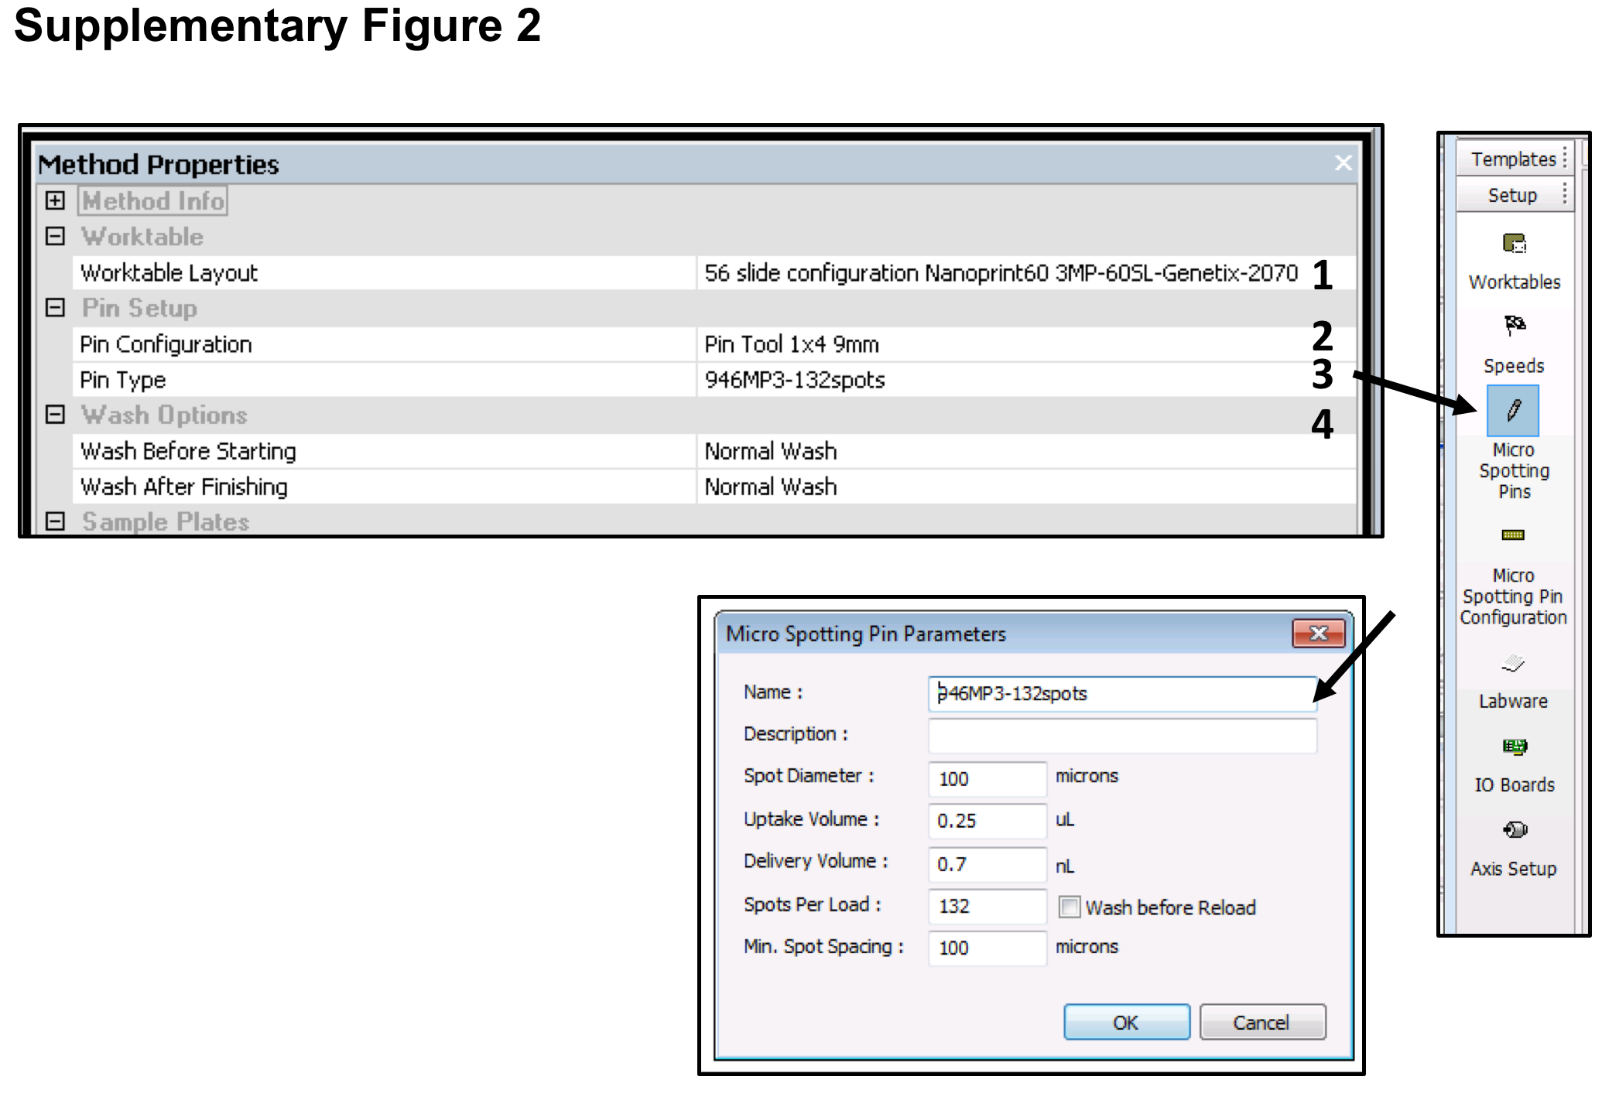

Supplementary Figure 2. Setting Method Properties. The worktable layout is defined according to the type of 384-well plate and number of slides to be printed. The Pin configuration is set to 4 pins of 9 mm and the Pin type is calculated to have 132 spots per dip. The washes are normal washes (4 cycles of sonication, washing and drying).

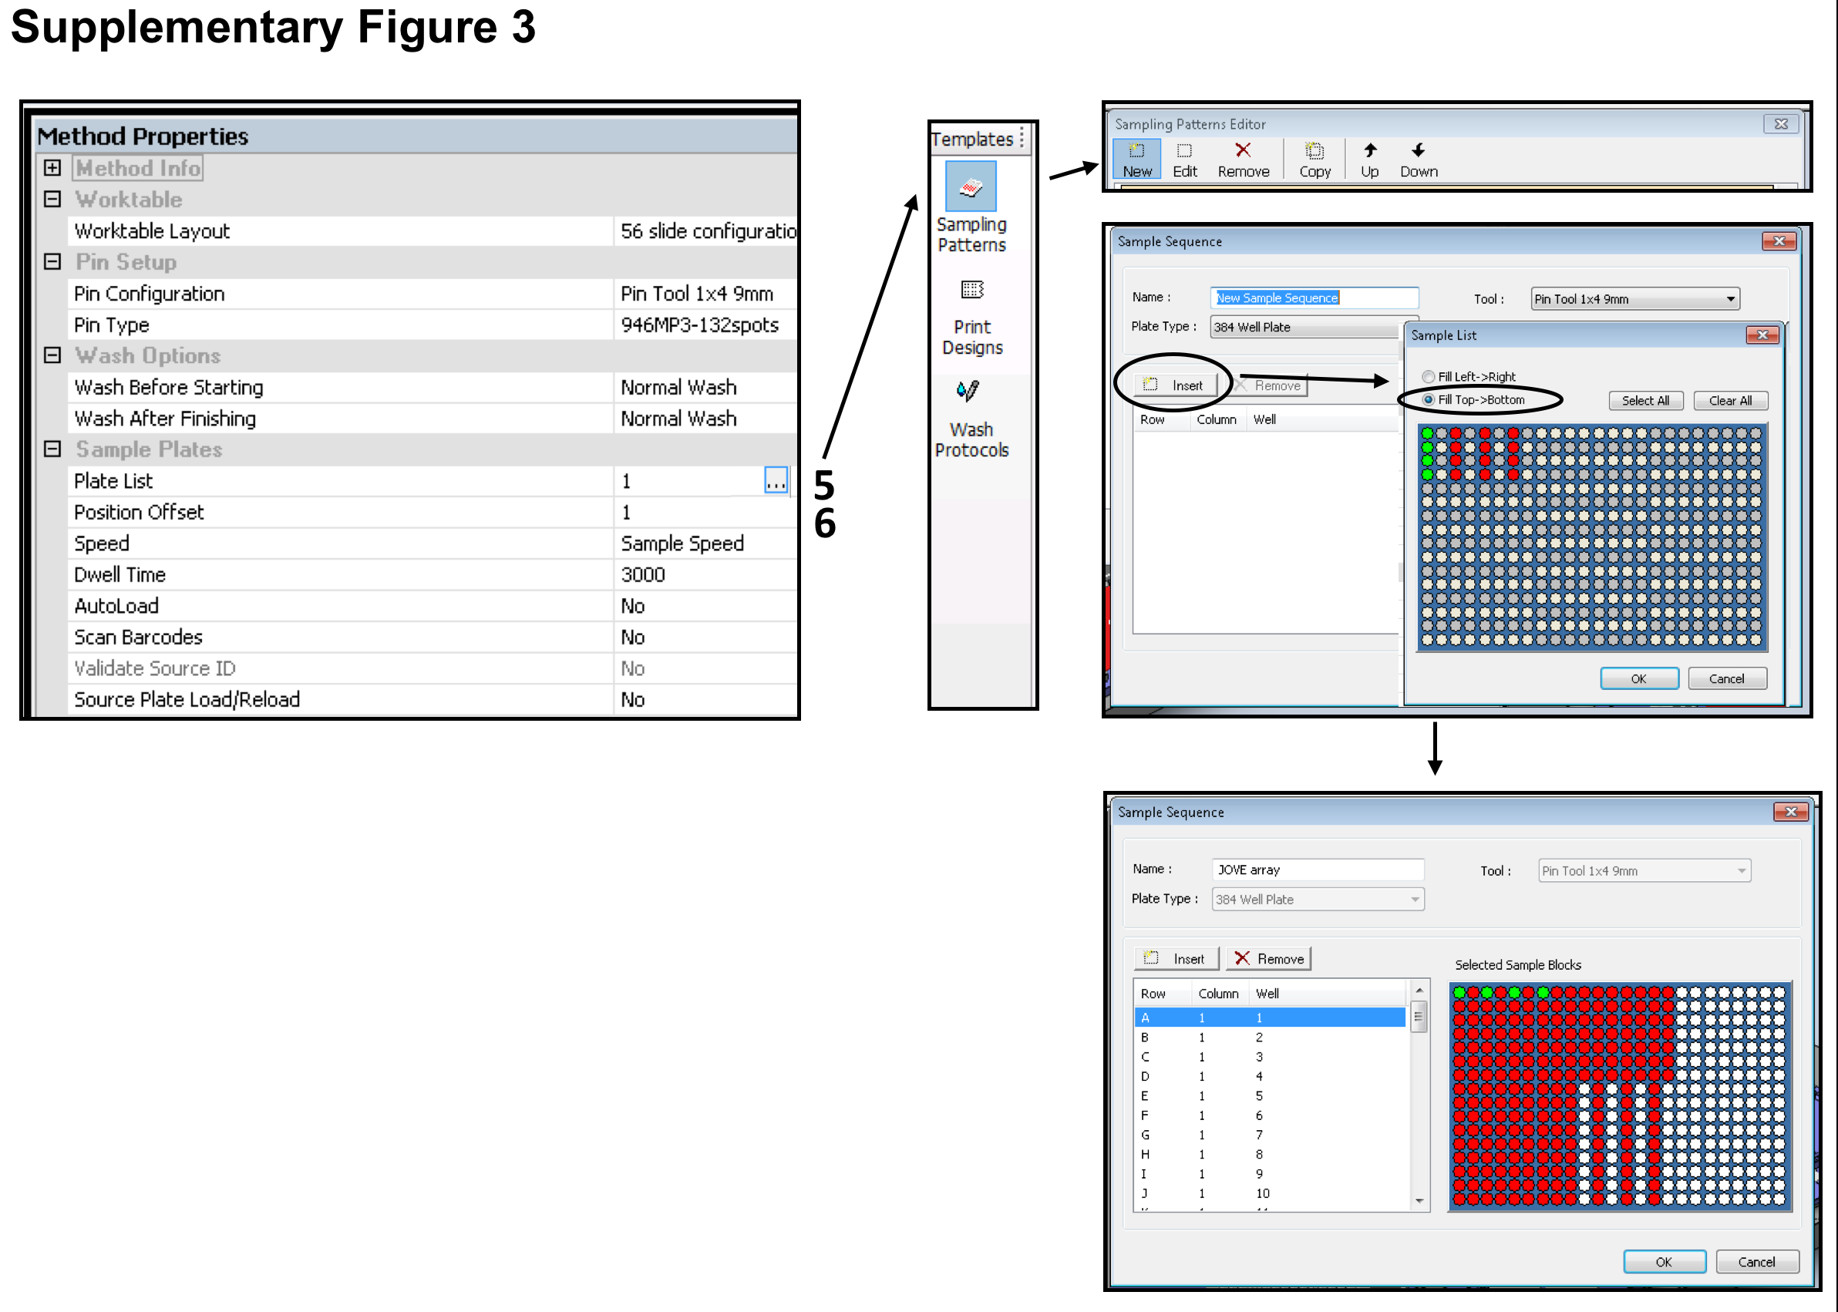

Supplementary Figure 3. Defining sampling pattern. In order to determine the order of uptakes from the 384-well plate, a sampling pattern is defined and saved as a source plate with a name. This plate sampling order is then entered to the Plate List window.

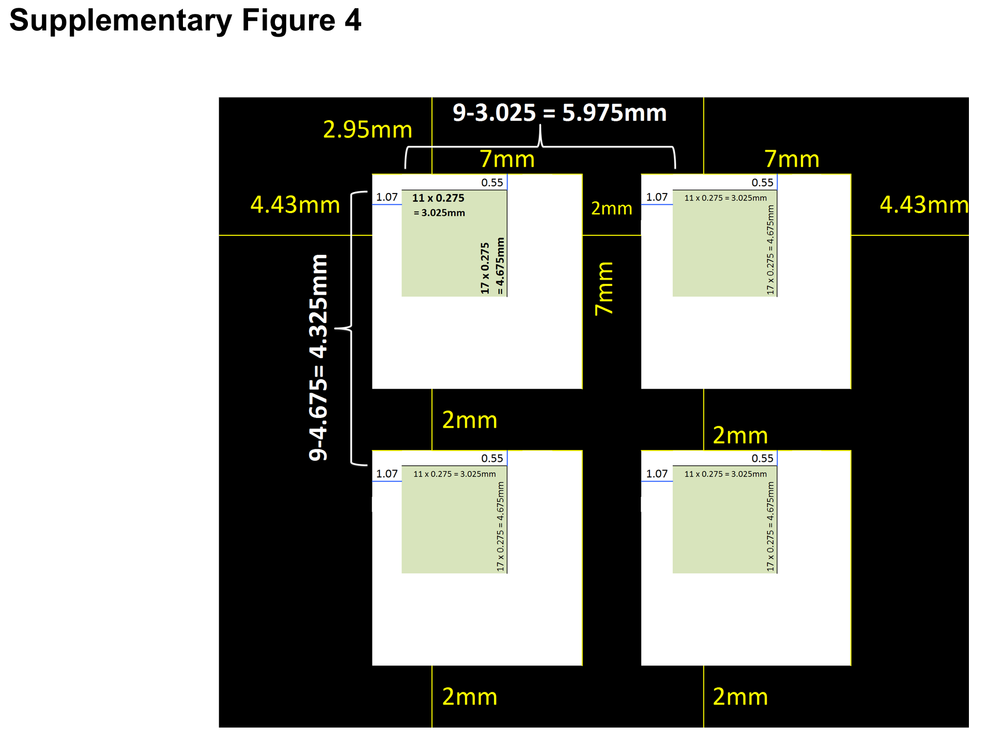

Supplementary Figure 4. Schematic illustration of the 4 upper sub-arrays on the slide. Each Sub-array has 12 columns and 18 rows and the distances can be calculated since the slide divider creates wells of 7 × 7 mm and has 2 mm spacing between wells. Therefore, the overall distance between two blocks is 9 mm and the distances between two Sub-Arrays is 9 mm minus the array size (vertical and horizontal).

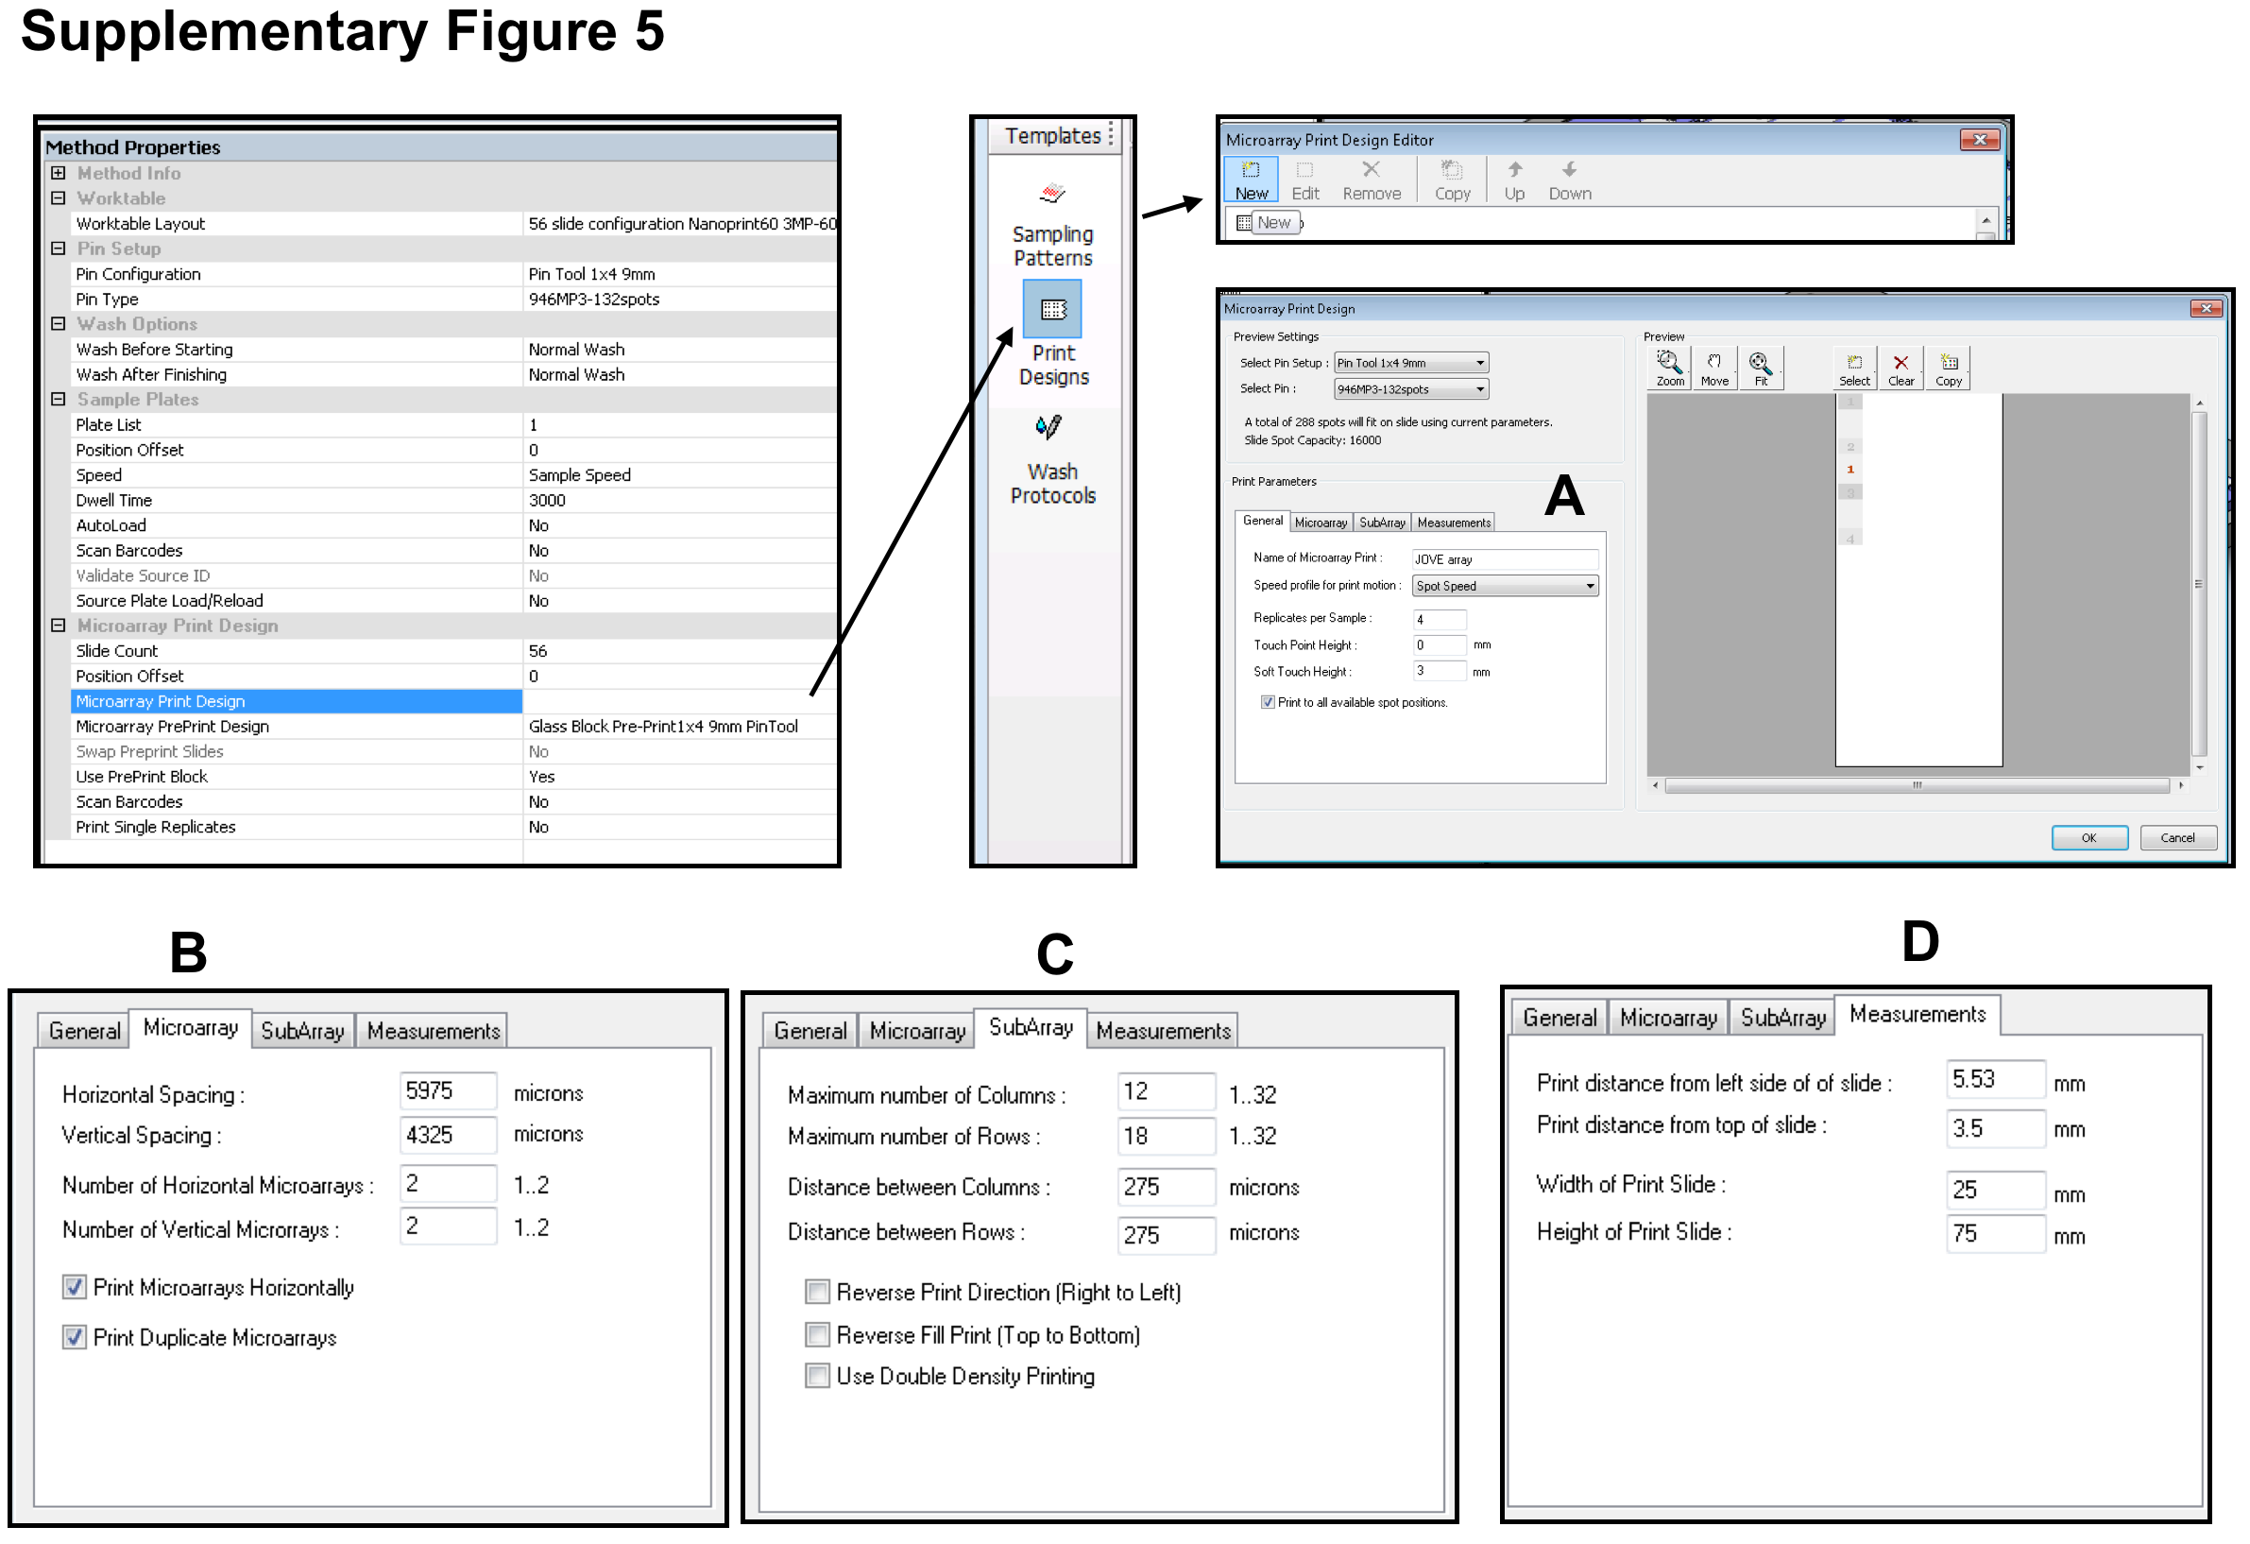

Supplementary Figure 5. Microarray Print Design. In order to define Print design the block layout information, distances, slide dimensions and printing options is set.

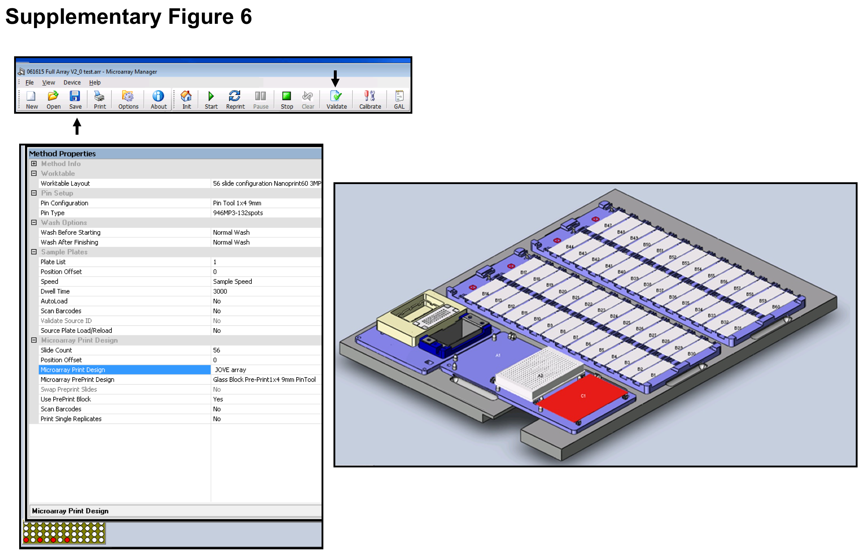

Supplementary Figure 6. Validation of method and saving as .arr file. The method programing must be validated and saved.

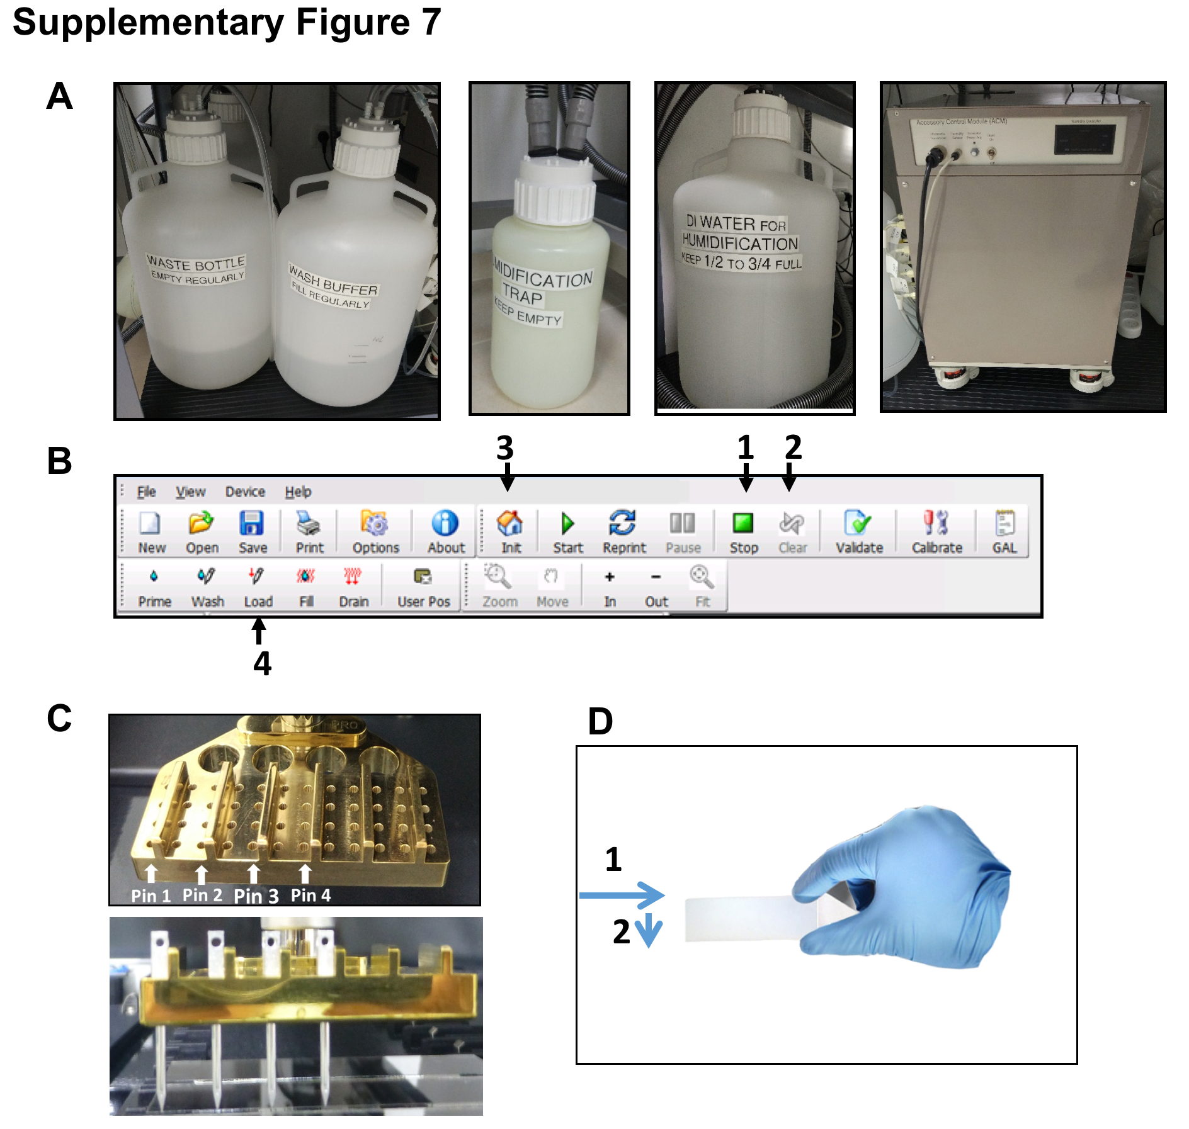

Supplementary Figure 7. Print initiation steps. A) left to right: Wash buffer carboy to be filled with DIW, Wash bottle (Drain) Carboy to be drained, Humidification trap to be drained, DIW for humidification to be filled and humidification machine control. B) Control panel of the ‘Microarray Manager’ software. Numbers indicating the steps needed to be done in order to initiate pins loading. C) Print-head. Numbers indicate the specific location of the 4 pins that are suitable for the define printing layout. D) Slide placing illustration on the array deck.

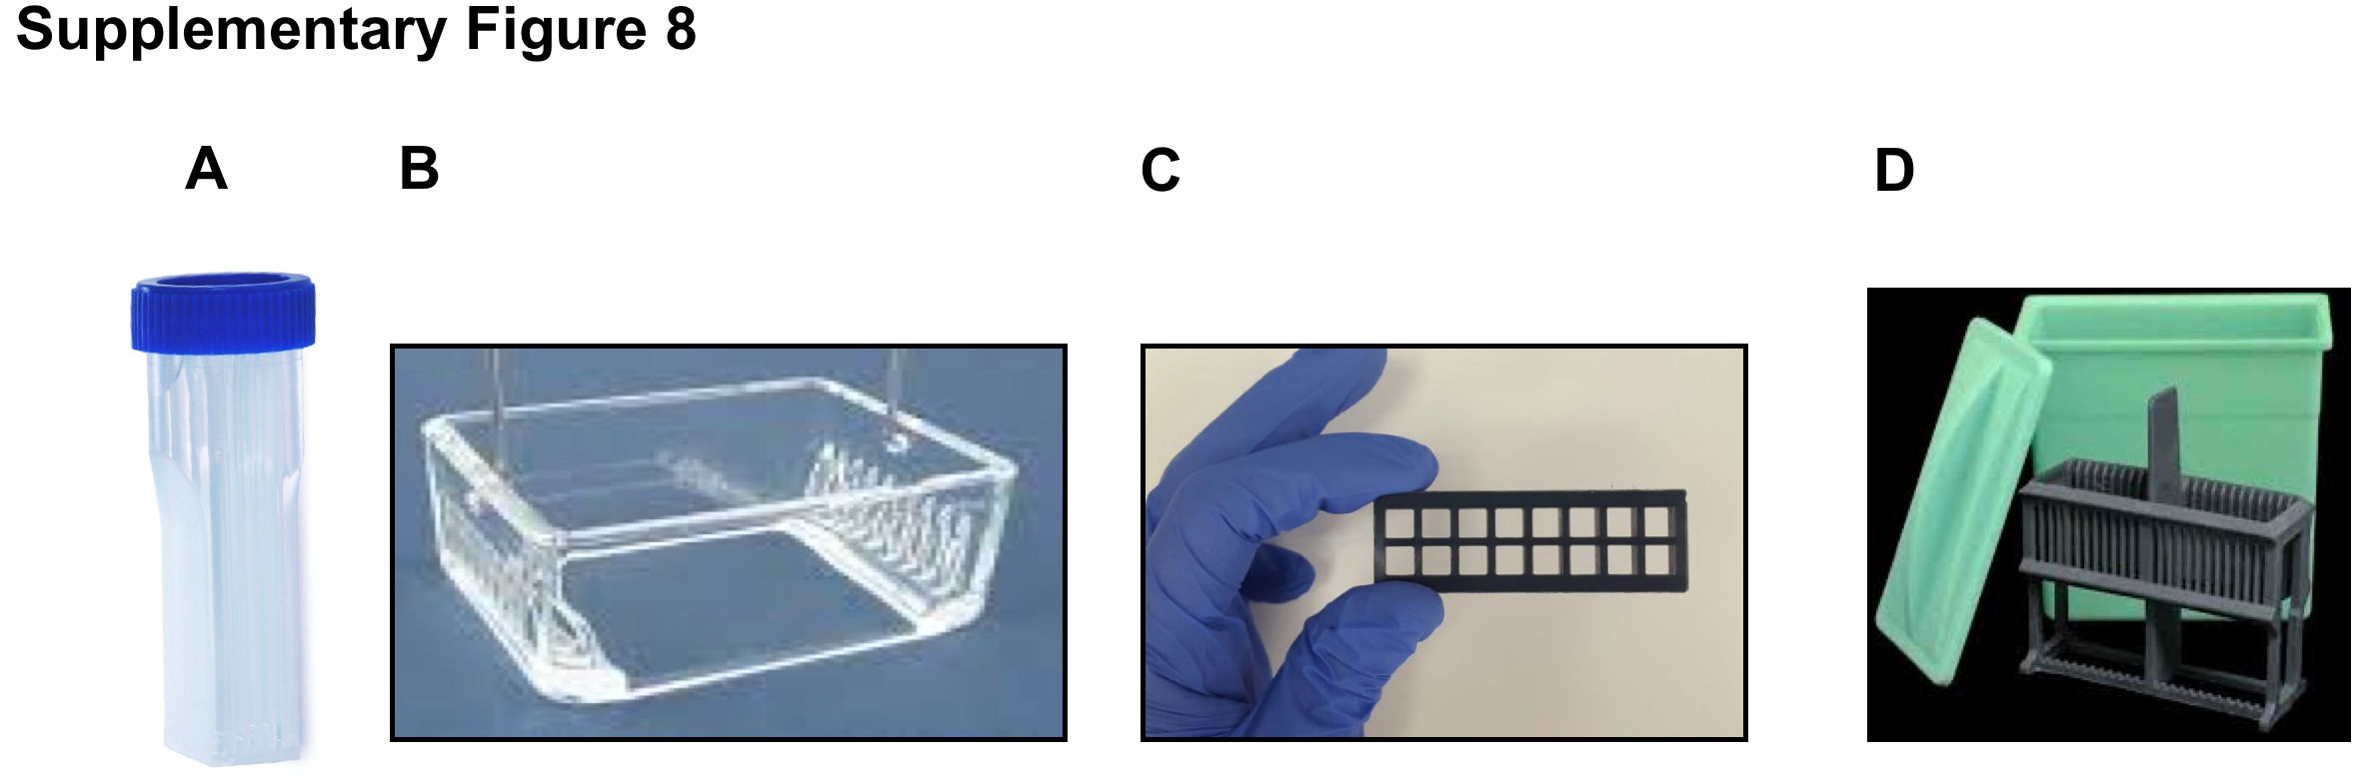

Supplementary Figure 8. Staining tools for developing the slide. A) Staining 50 ml tube. B) Glass Staining holder. C) ProPlate 16-well divider. D) Staining bath.

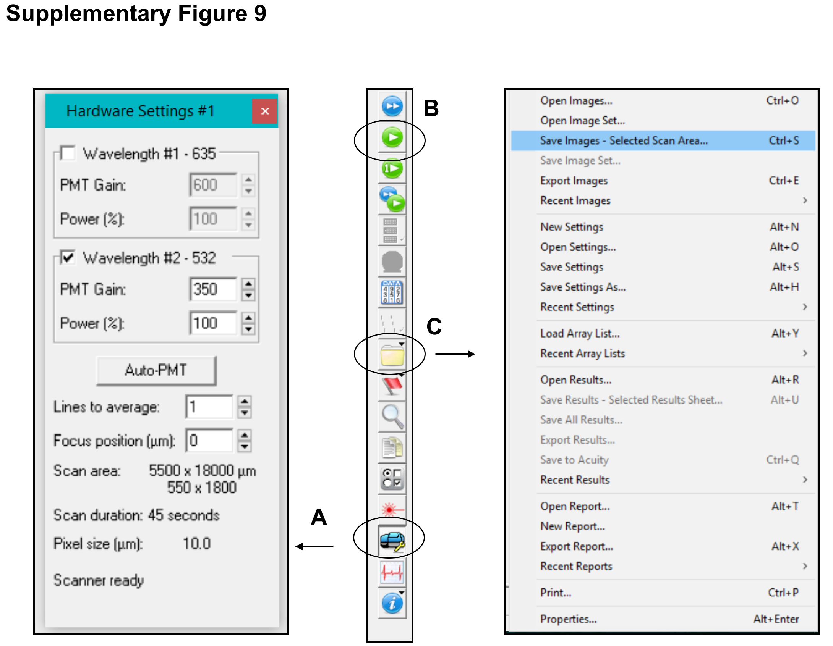

Supplementary Figure 9. Setting scanning parameters. A) One or two wavelength can be selected then the power and gain are set after calibration. The focus position is set to 0 and Line to average to 1. These parameters can be adjusted to fit different experiments. B) Start scanning. C) Save the Image you scanned as tiff image.

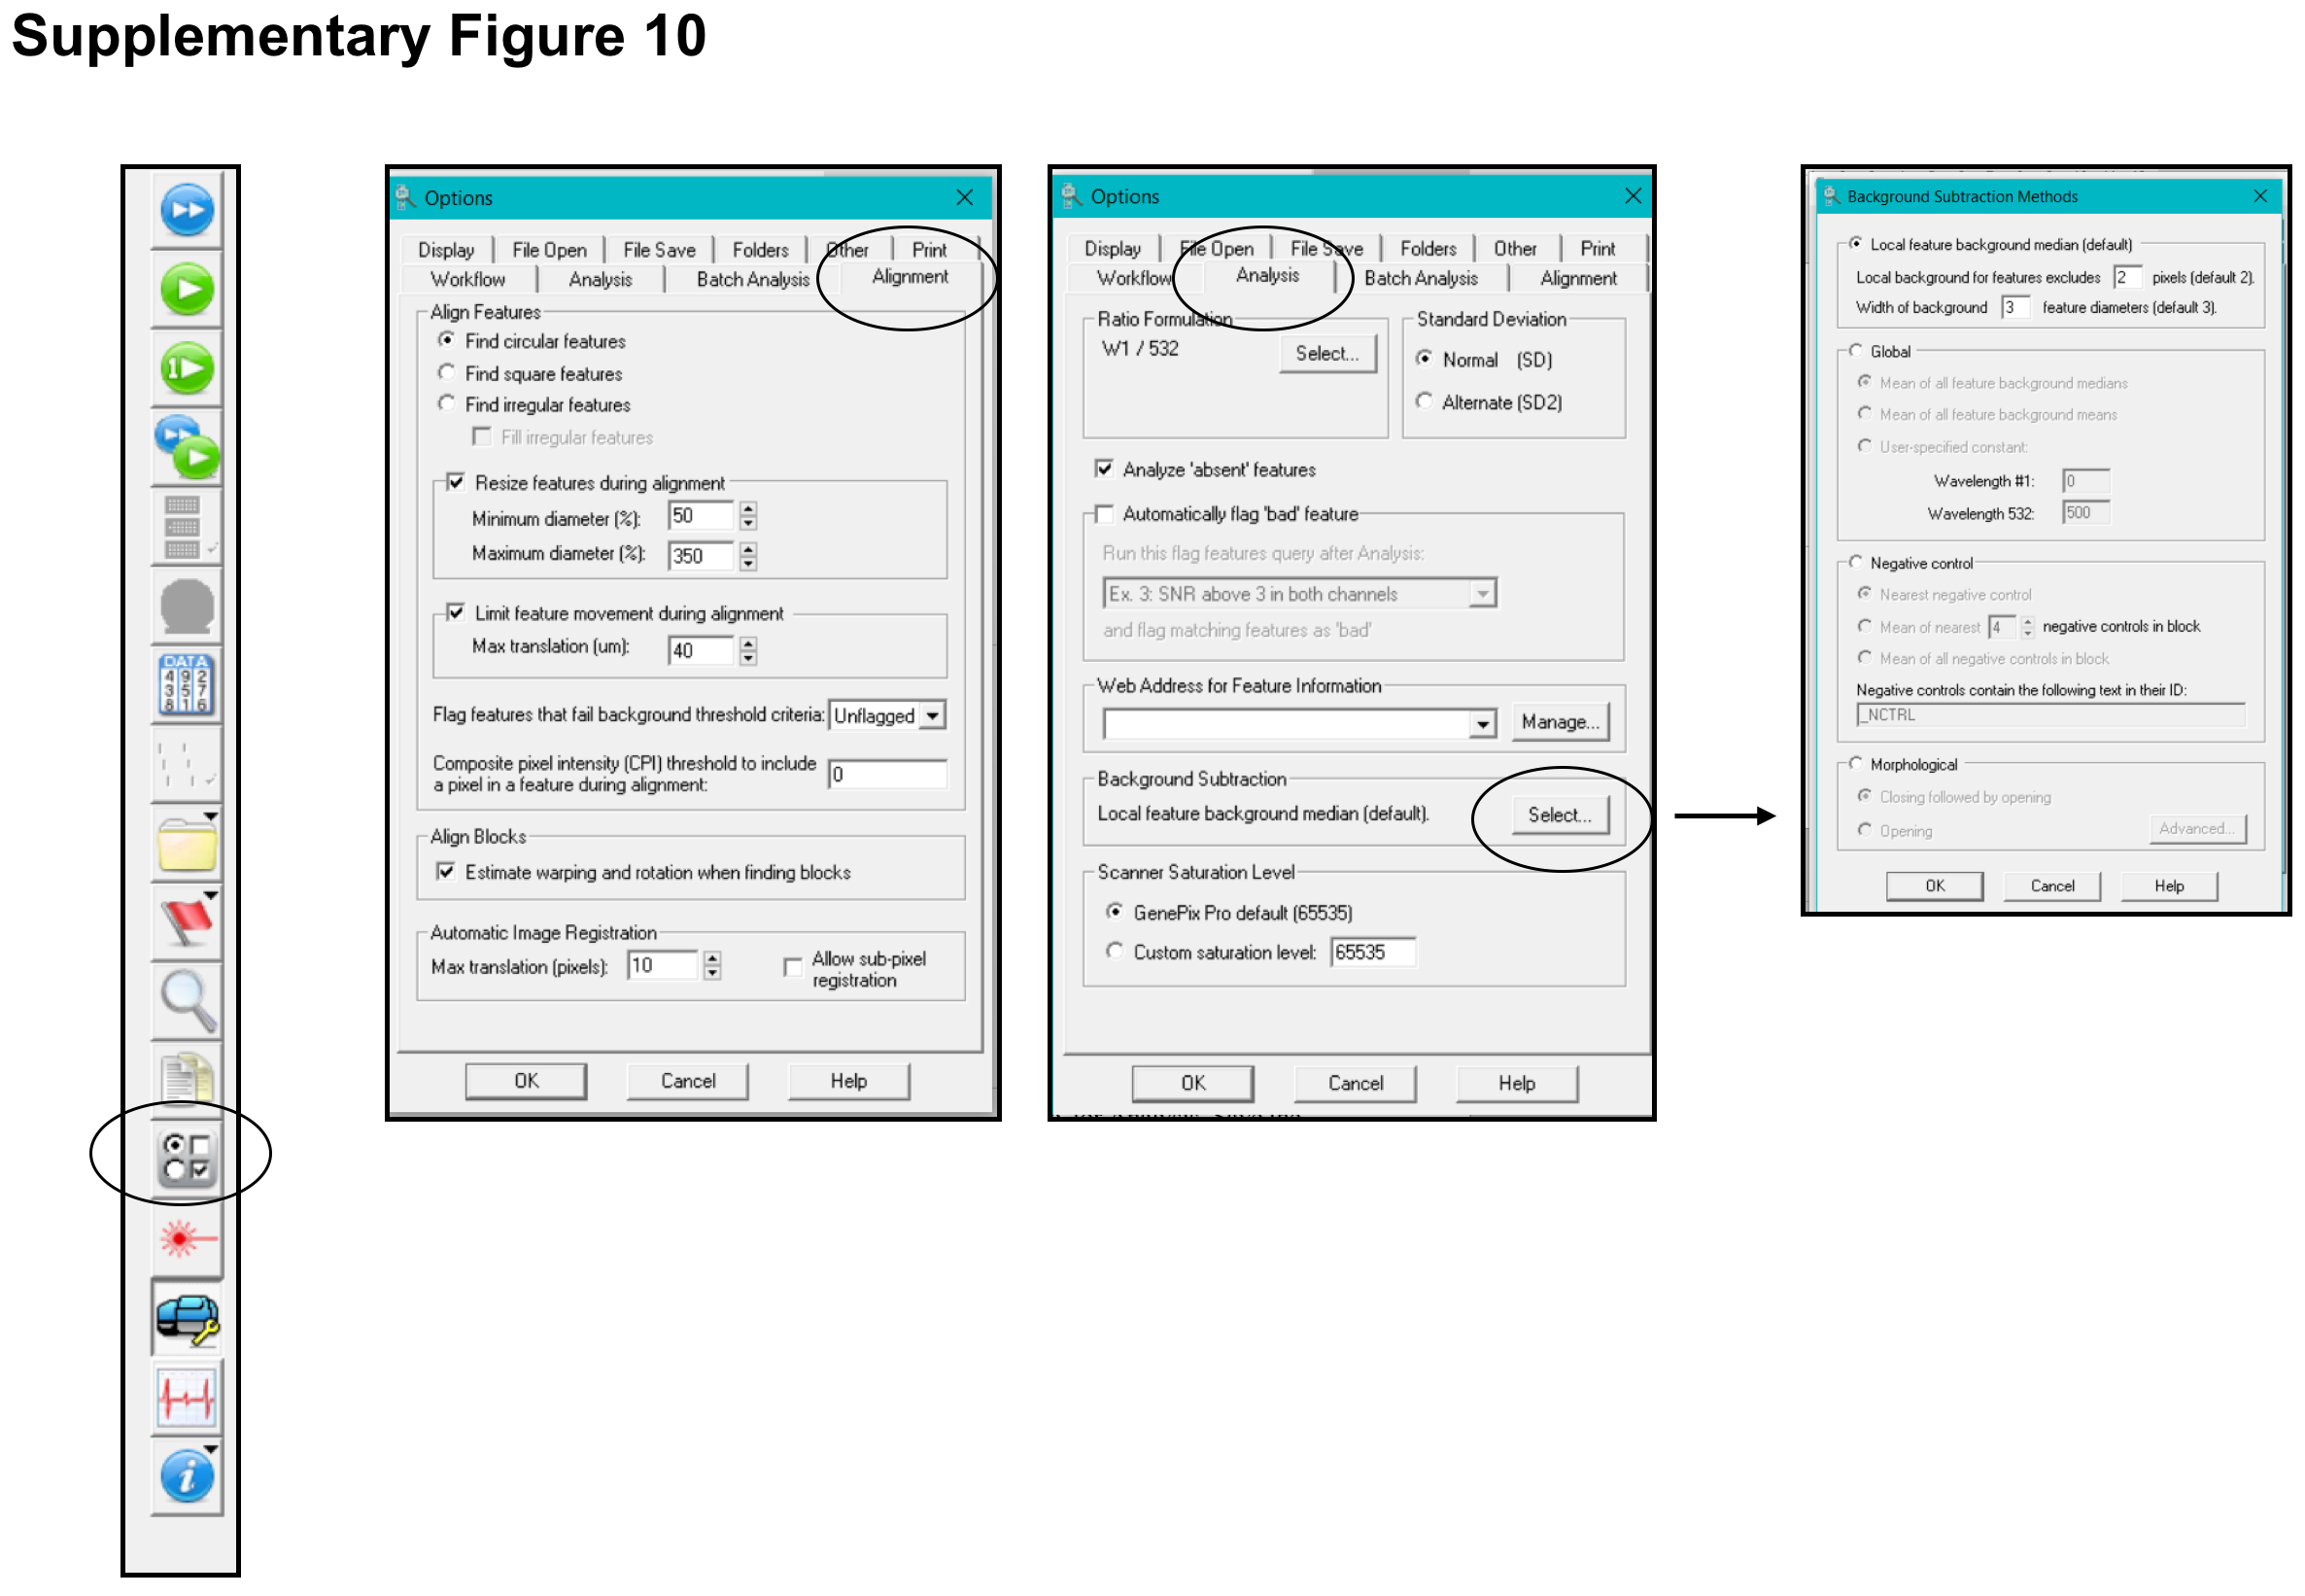

Supplementary Figure 10. Defining alignment and analysis parameters. Flexibility of alignment and analysis setting can be calibrated, including background subtraction algorithm.

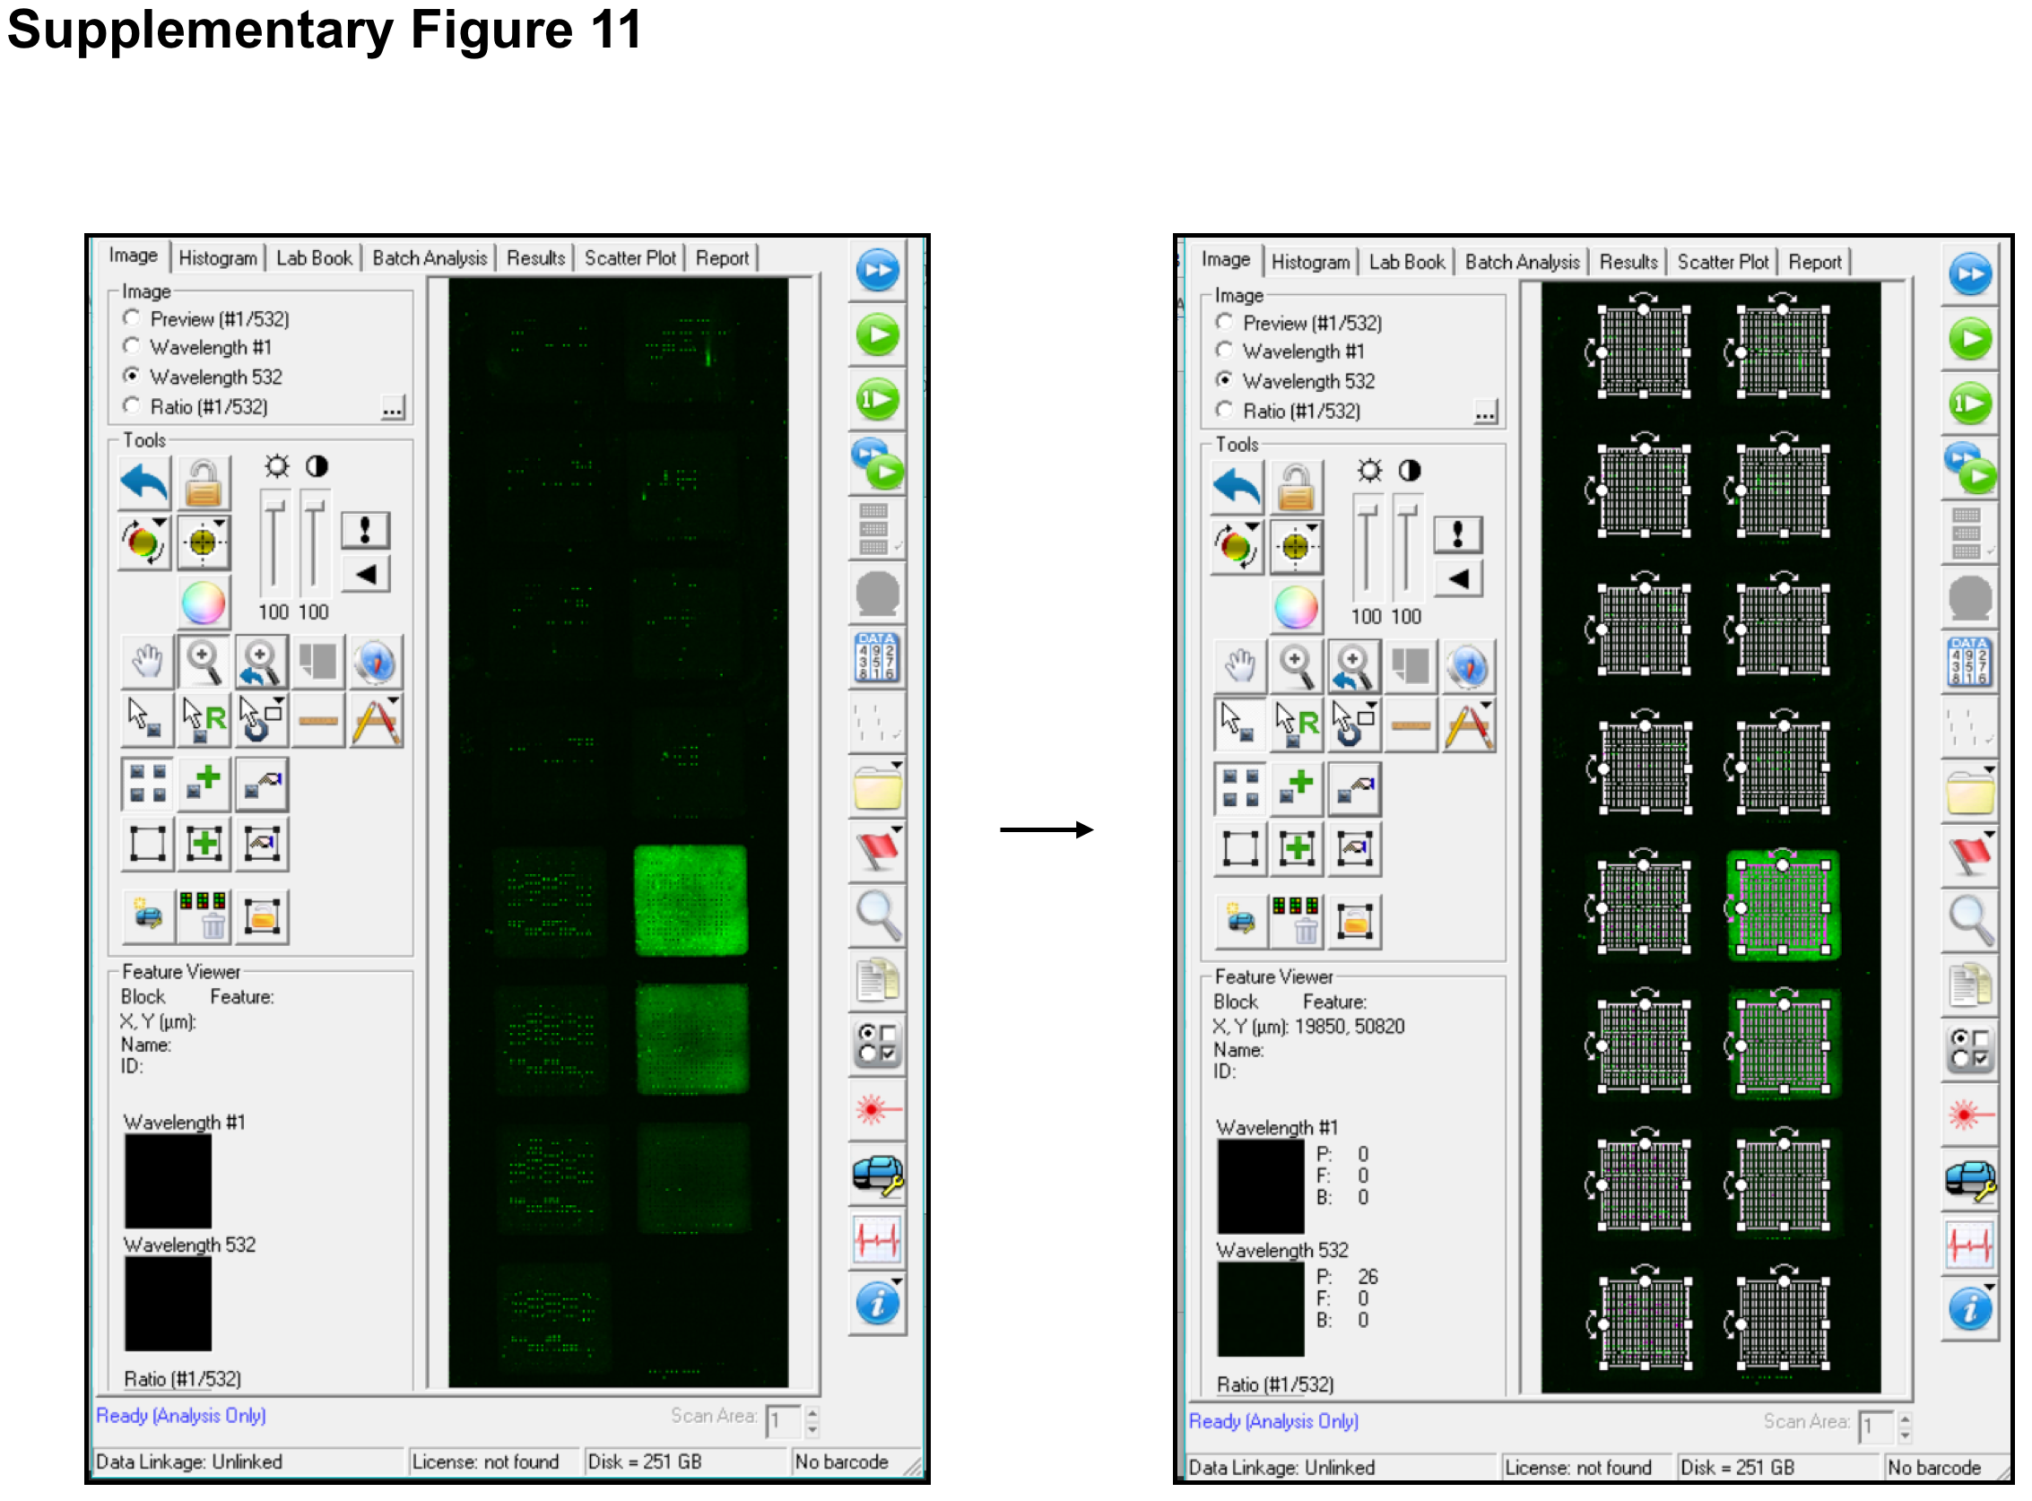

Supplementary Figure 11. Loading GAL file and alignments. Align the grids according to the upper left corner of slide, then align each block individually to ensure proper fit.

